Instructions for adding meeting background

1. Open VooV Meeting or Tencent Meeting App, and log in.
2. Click your image on the top left corner.
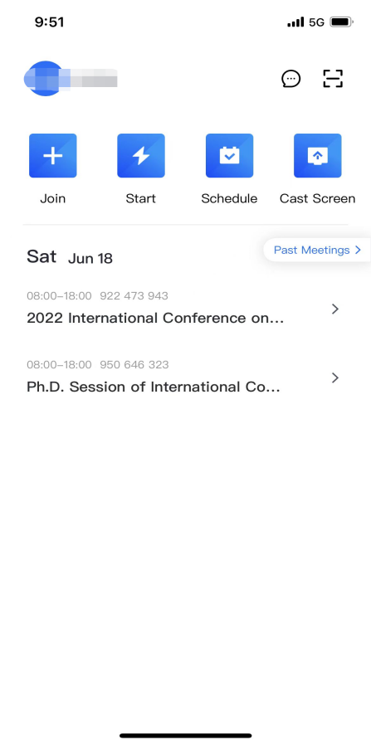
- Enter the settings page.
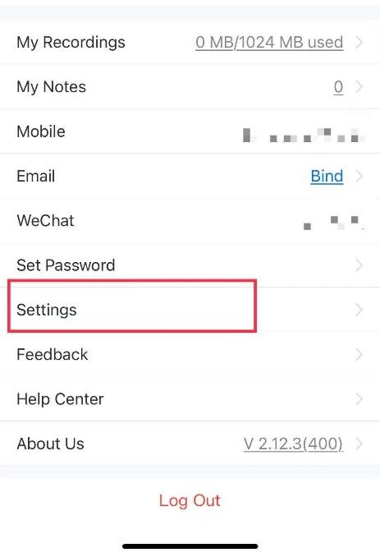

- Click background, and add the picture attached.
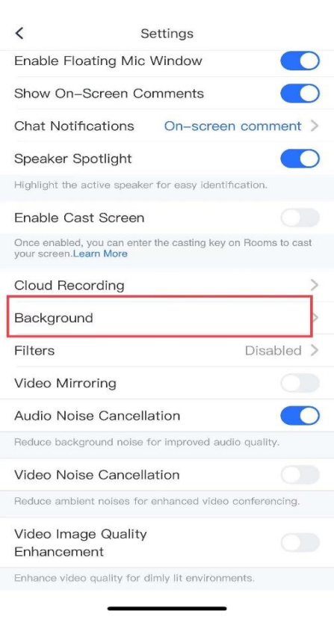

Background:

