Ⅰ.对于国内参会者
- Session One & Session Two & Session Three & Session Four :
2023 International Conference on Industrial Economics
2023/07/06 08:30-17:00 (北京时间)

点击链接入会，或添加至会议列表：https://meeting.tencent.com/dm/QHh3RZjvdf6B

#腾讯会议：738-170-465
会议密码：0706

- Session Six & Session Seven:
2023 International Conference on Industrial Economics
2023/07/07 08:30-12:20 (北京时间)

点击链接入会，或添加至会议列表：https://meeting.tencent.com/dm/xlFHLPKKHM25

#腾讯会议：666-539-773
会议密码：0707

- Session Eight:
2023 International Conference on Industrial Economics
2023/07/07 10:40-12:20(北京时间)

点击链接入会，或添加至会议列表：https://meeting.tencent.com/dm/DDHi6CtQZhKO

#腾讯会议：345-374-760
会议密码：0707

Ⅱ. For attendees abroad
Download “Voov Meeting” in IOS APP Store, Android APP Store.
If you want to download it in your pc, click here and follow the instructions.
https://voovmeeting.com/download-center.html?from=1001

Session One & Session Two & Session Three & Session Four :
2023 International Conference on Industrial Economics
Schedule time: 2023/07/06 08:30-17:00 (GMT+08:00)
Meeting ID：738-170-465
Password：0706
Click the following link or open the website in browser.
https://meeting.tencent.com/dm/QHh3RZjvdf6B

Session Six & Session Seven:
2023 International Conference on Industrial Economics
Schedule time: 2023/07/07 08:30-12:20 (GMT+08:00)
Meeting ID：666-539-773
Password：0707
Click the following link or open the website in browser.
https://meeting.tencent.com/dm/xlFHLPKKHM25

Session Eight:
2023 International Conference on Industrial Economics
Schedule time: 2023/07/07 10:40-12:20 (GMT+08:00)
Meeting ID：345-374-760
Password：0707
Click the following link or open the website in browser.
https://meeting.tencent.com/dm/DDHi6CtQZhKO

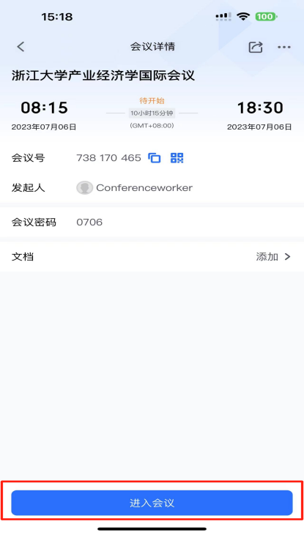
Click Join Now

Open in “Voov” in the new pop-up window.
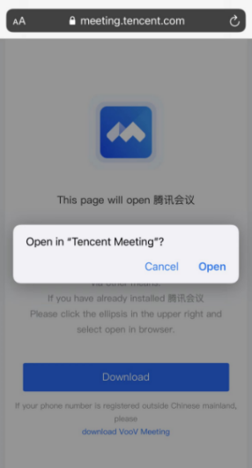

Instructions for adding meeting background

- Open VooV Meeting or Tencent Meeting App, and log in.

2. Click your image on the top left corner.

- Enter the settings page.
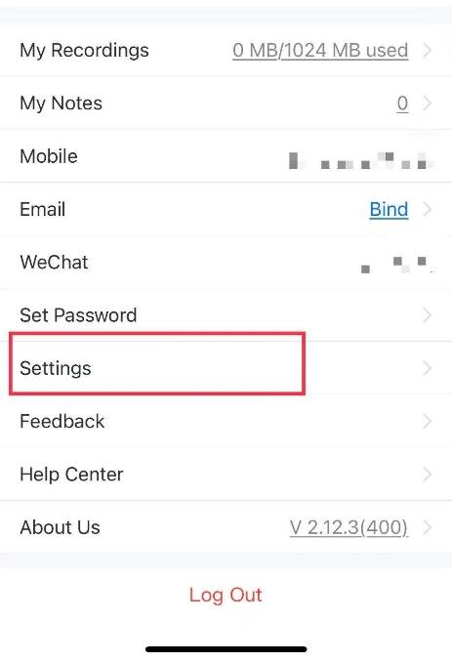

- Click background, and add the picture attached.
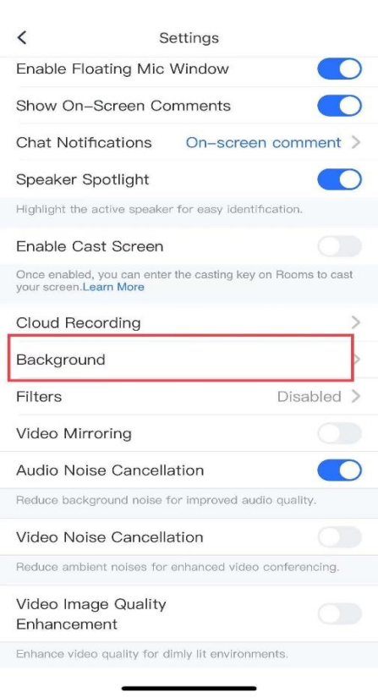

Background:

